Eureka College Canvas Tutorials

How do I manage/view my Canvas Credentials(Parchment)/Backpack account?
You can create a Parchment Digital Badges/Credentials account and manage the emails and passwords associated with it. You can add additional email addresses, change your primary email address, add email case variants, remove email addresses from your account, or change your password. You can also merge accounts.
Parchment Digital Badges/Credentials allows you to add multiple email addresses to your account from the Profile page. Adding additional email addresses to an account enables you to collect badges awarded to different email addresses (e.g., institution, work, volunteer) all in one backpack account.
Badges are awarded to a specific email address and are permanently associated with that email. We strongly recommend associating a personal email with your Parchment Digital Badges/Credentials account, so you can maintain access to your account and badges in case you lose access to a work or institution email at a future date.
If you do not already have an account, go to https://badges.parchment.com/auth/login and enter your email to create a new account. If you already have an account, click the Sign In link at the top to access your account. You can use any email you want, it does not need to be your Eureka College email.
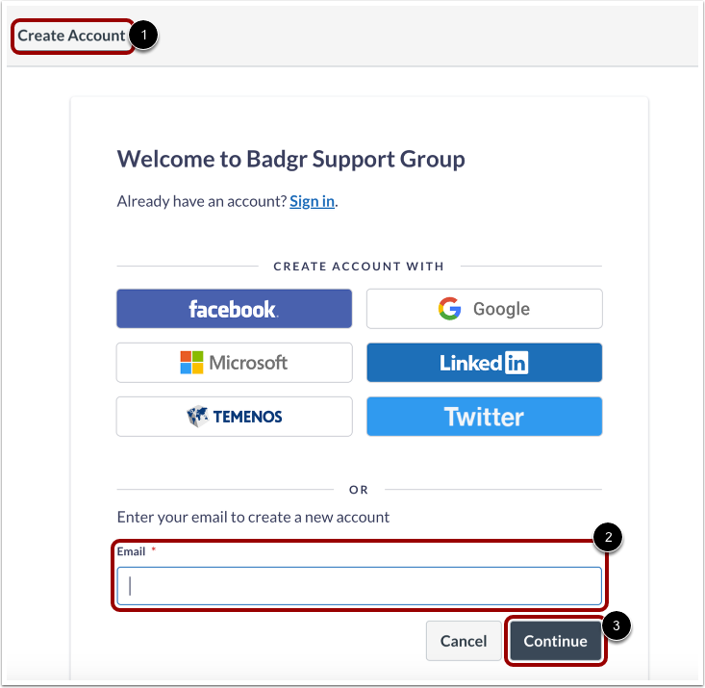
Then click the Continue button. You will then need to go to your email to get the verification code. This code will go to the email you have just entered.
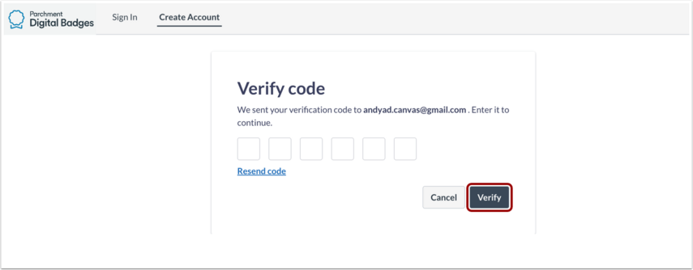

Enter the verification code you received in your email, then click the Verify button.
Once you have verified, fill out the rest of the personal information within the Complete Signup form, including creating a unique password.
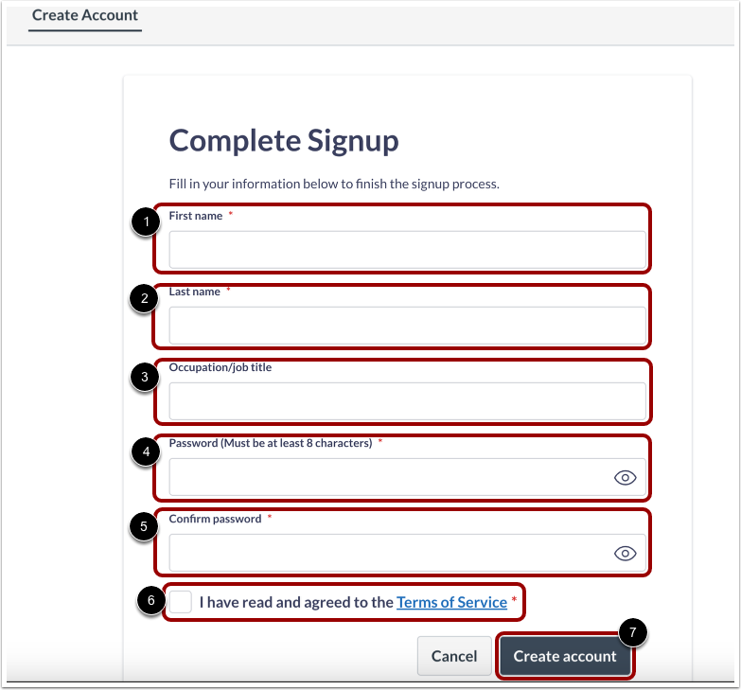
Users should have received an email notifying them that they have been subscribed to a pathway. Once the user is logged in to Credentials, you can view that pathway, along with the badges earned within the account.
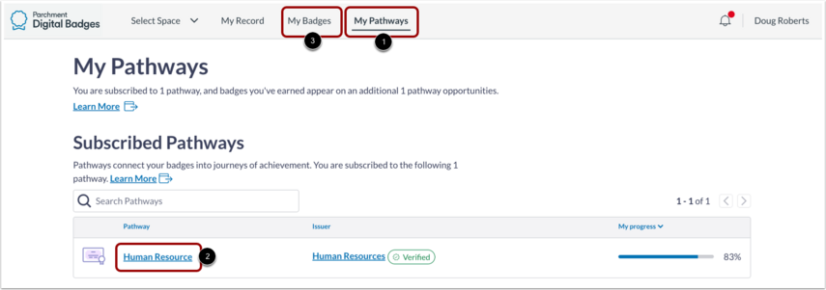
If you click the Pathways tab, you can view the steps you have completed and your progress. If you believe your progress is not up to date or not appearing on a pathway, please contact your advisor or the Canvas Administrator.
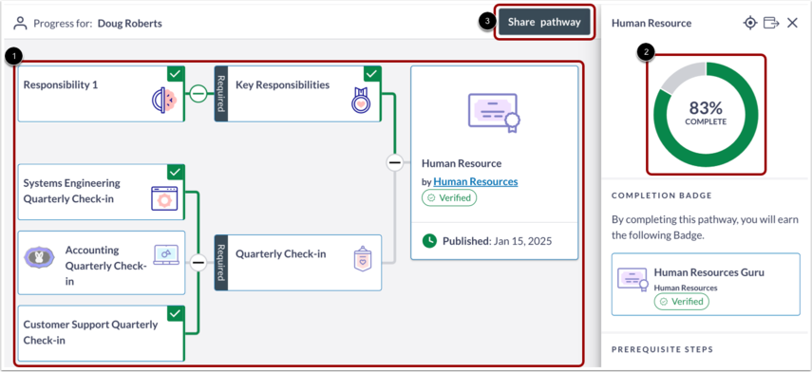
- If all badges and manual experiences prerequisite steps are fulfilled, a step is considered complete.
- Learners with criteria unmet with not count toward step or pathway completion.
If you click the Badges tab, you can view the milestone badges you have earned. If you believe you are missing a milestone badge, please contact your advisor or Canvas Administrator.

